HOME CREDIT DEFAULT RISK
Complete Analytical Report
Data Cartography · Data Deep Dive · Signal Extraction · From Models to Decisions
REPORT DETAILS
Student | Devanathan
Programme | MBA
Sessions Covered | Session 13, 13B, 14, 15, 16, 17
Dataset | Home Credit Default Risk (Kaggle)
Total Applications | 307,511
Date | April 2026
Sessions in Report | 6 (13 → 13B → 14 → 15 → 16 → 17)

REPORT ABSTRACT
This report documents the complete data science analysis and modelling workflow for the Home Credit Default Risk dataset across six sessions. Session 13 (Data Cartography) established the structure of 8 interconnected tables totalling 56 million rows. Session 13B (Data Deep Dive) performed bivariate analysis and produced a ranked feature scorecard. Session 14 (Signal Extraction) formalised these findings through variance filters, correlation screening, PCA, and Factor Analysis, delivering two reduced feature sets. Sessions 15–17 (From Models to Decisions) used those feature sets to build, calibrate, and interpret predictive models — regularised logistic regression, LightGBM, polynomial and spline extensions — and translated the results into SHAP-based explanations, partial dependence insights, and a draft credit policy with risk tiers and adverse-action templates. The report closes with the model comparison dashboard and a preview of the Session 18 capstone.

Table of Contents

1. Executive Summary 3

2. Session 13 — Data Cartography 4
2.1 Business Context & Problem Statement 4
2.2 Dataset Architecture (8 Tables) 4
2.3 Central Table Feature Groups 5
2.4 Data Quality: DAYS_EMPLOYED Anomaly 5
2.5 External Credit Scores 5
2.6 Missingness Landscape 6
2.7 Multi-Table Join Strategy & Validation 6
2.8 Derived KPIs 7

3. Session 13B — Data Deep Dive 8
3.1 Categorical Features vs Default 8
3.2 Numeric Features vs Default (Box Plots & KDE) 8
3.3 Outlier Detection & Treatment 9
3.4 Feature Transformations 9
3.5 Cross-Feature Interactions 10
3.6 Correlation Landscape 10
3.7 Feature Scorecard 11

4. Session 14 — Signal Extraction 12
4.1 Numeric Matrix Preparation 12
4.2 Near-Zero Variance Filters 12
4.3 Correlation Screening 12
4.4 Principal Component Analysis (PCA) 13
4.5 Factor Analysis 14
4.6 PCA vs Factor Analysis Comparison 14
4.7 Feature Reduction Pipeline & Output 14

5. Sessions 15–17 — From Models to Decisions 16
5.1 Feature Reload & Train/Test Split 16
5.2 Baseline: Regularised Logistic Regression 16
5.3 Gradient Boosting: LightGBM 17
5.4 Model Calibration 17
5.5 Complexity Trade-offs: Polynomial Features & Splines 18
5.6 SHAP: Global Interpretability 19
5.7 SHAP: Individual Explanations 19
5.8 Partial Dependence Plots 19
5.9 Policy Translation: Risk Tiers & Draft Credit Policy 20
5.10 Model Comparison Dashboard & Decision Blueprint Preparation 21

6. Key Findings Across All Six Sessions 23

1. Executive Summary
This report covers six sessions of data science work on the Home Credit Default Risk dataset — from raw data exploration through to a deployable credit policy. The objective is to predict whether a loan applicant will default (TARGET = 1) or repay on time (TARGET = 0), using a multi-table dataset of 307,511 applications and 56 million total rows across 8 tables.

Sessions 13 · 13B · 14 | Sessions 15–17
Mapped all 8 tables, cleaned the DAYS_EMPLOYED anomaly, built a ranked Feature Scorecard, and reduced ~108 numeric features to a decorrelated set (~62) and a PCA set (~27 components). | Built and compared 5 models — L1/L2 logistic regression, LightGBM, polynomial and spline extensions — reaching AUC-ROC 0.7518 with LightGBM, then used SHAP and PDPs to translate the winning model into a draft credit policy with 5 risk tiers.

The work takes the raw dataset from 122 columns in a single table to a production-ready model with an explainable, business-ready decision policy. Every modelling choice — which algorithm, which threshold, which features to keep — is documented with its rationale and trade-offs.

Six-Session Summary at a Glance

Session | Focus | Headline Result
13 — Data Cartography | Mapped all 8 tables and their relationships | DAYS_EMPLOYED anomaly found in 55,374 records; EXT_SOURCE identified as top predictor family
13B — Data Deep Dive | Bivariate analysis of every major feature | Ranked Feature Scorecard built; Young + Low Income = highest default zone
14 — Signal Extraction | Formal feature reduction pipeline | PCA: 90% variance in ~27 components; Factor Analysis names 6 business constructs
15 — Scalable Baselines | Regularised logistic regression & LightGBM | LightGBM reaches AUC-ROC 0.7518, +1.80 pts over logistic regression
16 — Complexity & Interpretability | Polynomial/splines, SHAP global & individual | Splines close ~5% of the linear-to-GBM gap while staying interpretable
17 — Policy Translation | PDPs, risk tiers, draft credit policy | 5-tier policy: Tier E (1.5% of applicants) carries 8.2% of all defaults

Session 13 — Data Cartography
Mapping the Data Universe — Structure, Quality & Schema

2.1 Business Context & Problem Statement
Home Credit Group operates in 9 countries serving the 'unbanked' population — people who have little or no traditional credit history. The business problem is a binary classification task: predict whether a loan applicant will repay on time (TARGET = 0) or experience payment difficulties (TARGET = 1), using alternative data sources beyond the traditional credit score.
The dataset contains severe class imbalance: only 8.07% of the 307,511 training applications are defaults. This means a naive model predicting 'no default' for every applicant achieves 92% accuracy while being completely useless. Correct evaluation metrics are AUC-ROC and AUC-PR, not accuracy.

Metric | Value | Implication
Total applications | 307,511 | Central fact table size
Default rate | 8.07% | Severe class imbalance
Imbalance ratio | 11.4 : 1 | Raw accuracy is meaningless
Primary metric | AUC-ROC / AUC-PR | Threshold-independent evaluation
Countries served | 9 | Multi-market consumer lender

2.2 Dataset Architecture — 8 Tables
The dataset follows a star schema with application_train as the central fact table. Six auxiliary tables fan out from it via two join keys: SK_ID_CURR (client ID) and SK_ID_PREV (previous application ID).

Table | Rows | Cols | Grain | Join Key
application_train | 307,511 | 122 | One row per current loan application | SK_ID_CURR
application_test | 48,744 | 121 | Current applications without TARGET | SK_ID_CURR
bureau | 1,716,428 | 17 | One row per previous credit bureau entry | SK_ID_CURR
bureau_balance | 27,299,925 | 3 | Monthly status per bureau credit | SK_ID_BUREAU
previous_application | 1,670,214 | 37 | One row per past HC application | SK_ID_CURR
POS_CASH_balance | 10,001,358 | 8 | Monthly POS/cash loan snapshots | SK_ID_PREV
credit_card_balance | 3,840,312 | 23 | Monthly credit card snapshots | SK_ID_PREV
installments_payments | 13,605,401 | 8 | Per-payment repayment history | SK_ID_PREV

Critical Rule: Granularity
Auxiliary tables have multiple rows per client. Joining directly to app_train inflates row counts. Always aggregate to SK_ID_CURR level first, then left-join. After every join, assert len(result) == 307,511.

2.3 Central Table Feature Groups
The application_train table has 122 columns spanning 6 groups:
- Identification & Target: SK_ID_CURR, TARGET — the primary key and prediction label. Zero missingness.
- Demographics & Employment: CODE_GENDER, DAYS_BIRTH, DAYS_EMPLOYED, NAME_EDUCATION_TYPE, OCCUPATION_TYPE (31% missing), CNT_CHILDREN.
- Financial Information: AMT_INCOME_TOTAL, AMT_CREDIT, AMT_ANNUITY (0.04% missing), AMT_GOODS_PRICE (0.9% missing).
- External Credit Scores: EXT_SOURCE_1 (56% missing), EXT_SOURCE_2 (0.2%), EXT_SOURCE_3 (20%). Strongest predictors in dataset.
- Property & Housing: 45 columns on building characteristics. Missingness 47–70%. Renters have no data — MAR pattern.
- Document & Enquiry Flags: 19 FLAG_DOCUMENT_* binary columns (99%+ zeros) and 6 AMT_REQ_CREDIT_BUREAU_* enquiry counts.

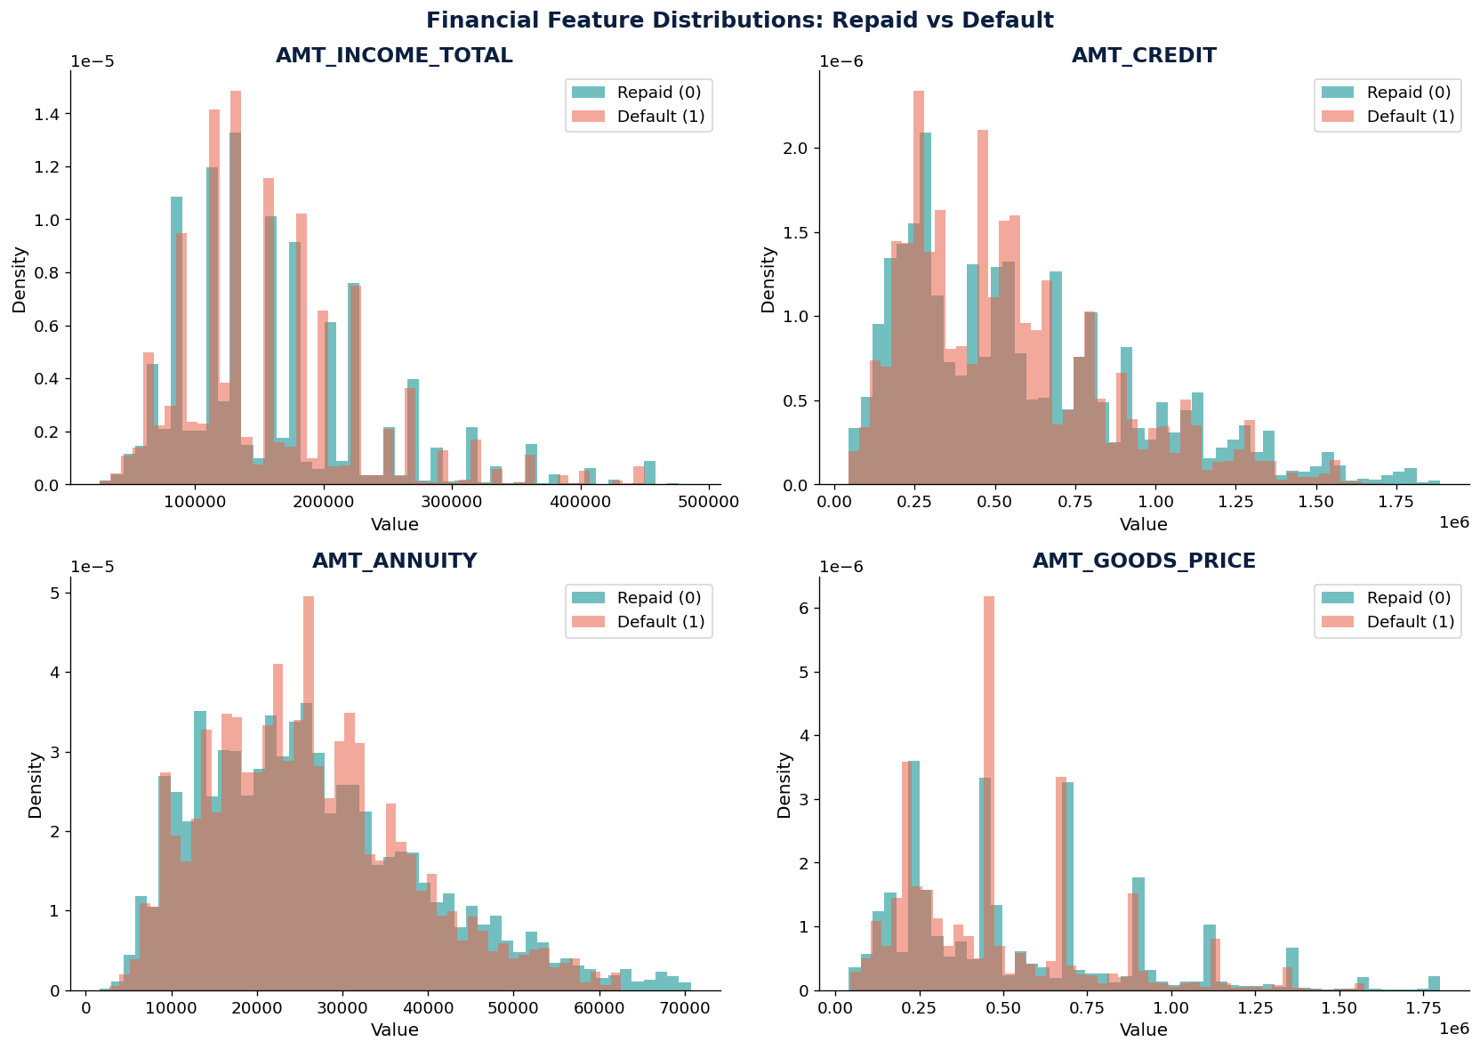
Figure 2.3a — Distribution of key financial variables (income, credit, annuity, goods price) split by repayment outcome.

2.4 Data Quality: DAYS_EMPLOYED Anomaly
DAYS_EMPLOYED contains the value 365,243 (approximately 1,000 years) in 55,374 records — a system placeholder for 'not traditionally employed'. This was detected, flagged, and cleaned.

Group | Record Count | Default Rate
Normal records (flag = 0) | 252,137 (81.99%) | 8.66%
Anomalous records (flag = 1) | 55,374 (18.01%) | 5.40%

Counterintuitively, anomalous records default less. These are likely pensioners and homemakers with stable (if informal) finances. The binary DAYS_EMPLOYED_ANOMALY flag is itself a useful predictive feature — and re-appears as an active model input in Session 15.

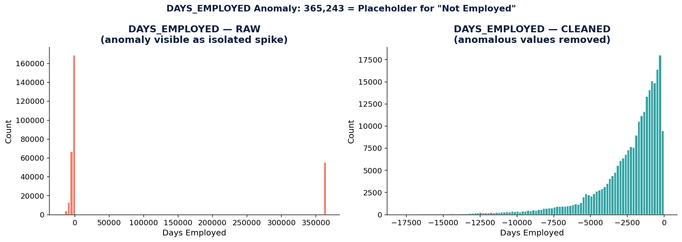
Figure 2.4a — DAYS_EMPLOYED before and after removing the 365,243-day placeholder anomaly.

2.5 External Credit Scores
EXT_SOURCE_1, 2, and 3 are normalised external bureau scores ranging from 0 to 1. They are the single most predictive features in the entire dataset.

Feature | Corr w/ TARGET | Missing % | Mean Repaid | Mean Default
EXT_SOURCE_1 | −0.1553 | 56.38% | 0.52 | 0.40
EXT_SOURCE_2 | −0.1605 | 0.21% | 0.52 | 0.40
EXT_SOURCE_3 | −0.1789 | 19.83% | 0.52 | 0.40
EXT_SCORE_BLEND | ≈ −0.19 | Varies | 0.52 | 0.40

The three scores are only weakly correlated with each other — meaning they capture independent dimensions of creditworthiness. Blending all three into EXT_SCORE_BLEND is more powerful than any individual score, and this blended feature becomes the single strongest driver of the LightGBM model in Session 15.

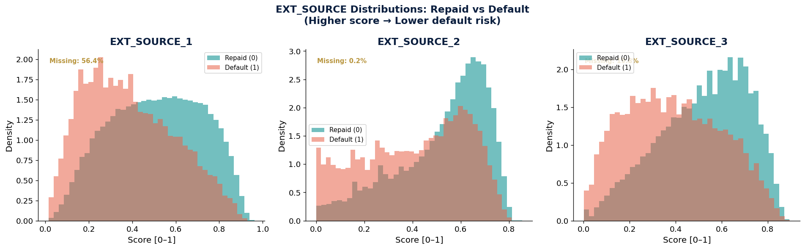
Figure 2.5a — EXT_SOURCE_1/2/3 distributions by repayment outcome, showing separation between repaid and defaulted applicants.
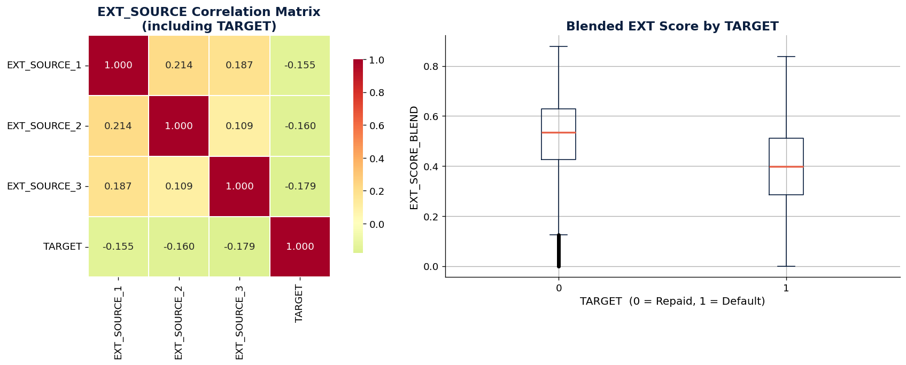
Figure 2.5b — EXT_SOURCE correlation matrix with TARGET and blended external score by repayment outcome.

2.6 Missingness Landscape
69 of 122 columns contain missing values. The pattern reveals three distinct mechanisms:

Feature Group | Missingness | Mechanism | Cols | Strategy
EXT_SOURCE_1 | 56.38% | MAR | 1 | Median impute + IS_MISSING flag
EXT_SOURCE_3 | 19.83% | MAR | 1 | Median impute + IS_MISSING flag
OCCUPATION_TYPE | 31.35% | MNAR | 1 | Create 'Unknown' category
Housing features | 47–70% | MAR | 45 | Drop or group-median impute
OWN_CAR_AGE | 65.99% | MAR | 1 | 0 for non-car owners + flag
AMT_REQ_CREDIT_BUREAU_* | ~13% | MAR | 6 | Impute 0 (no enquiries)

Missingness as Signal
In credit risk, missing data often carries predictive power. Missing OCCUPATION_TYPE correlates with higher default rates. Always create IS_MISSING flags before imputation — the flag itself may be more predictive than the imputed value.

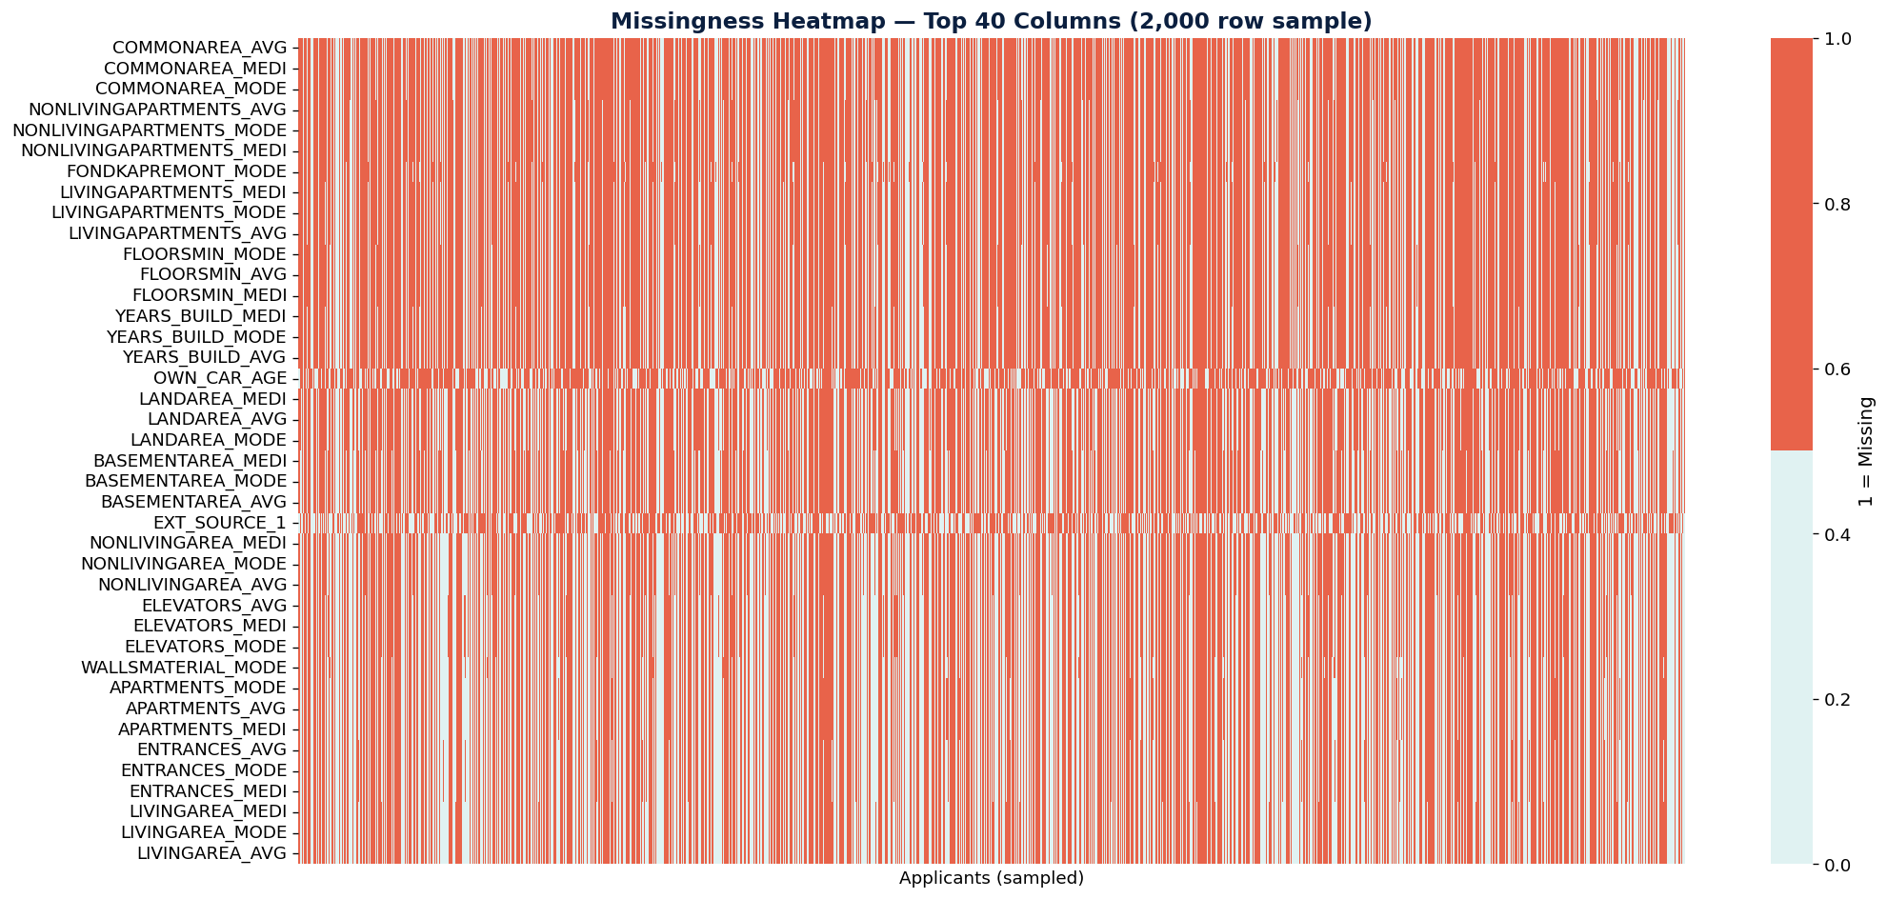
Figure 2.6a — Missingness heatmap for the 40 columns with the highest missing-value rates.

2.7 Multi-Table Join Strategy & Validation
The bureau table was aggregated to the SK_ID_CURR level and left-joined to app_train, adding 11 new engineered features while preserving the 307,511 row count exactly.

Validation Check | Result
Row count after join | 307,511 ✓ (matches app_train exactly)
Columns added | 11 new bureau aggregation features
Thin-file clients (no CB history) | 44,020 (14.3% of all applicants)
Unique SK_ID_CURR in bureau | 305,811 out of 307,511
Join type used | LEFT JOIN (preserves all applicants)

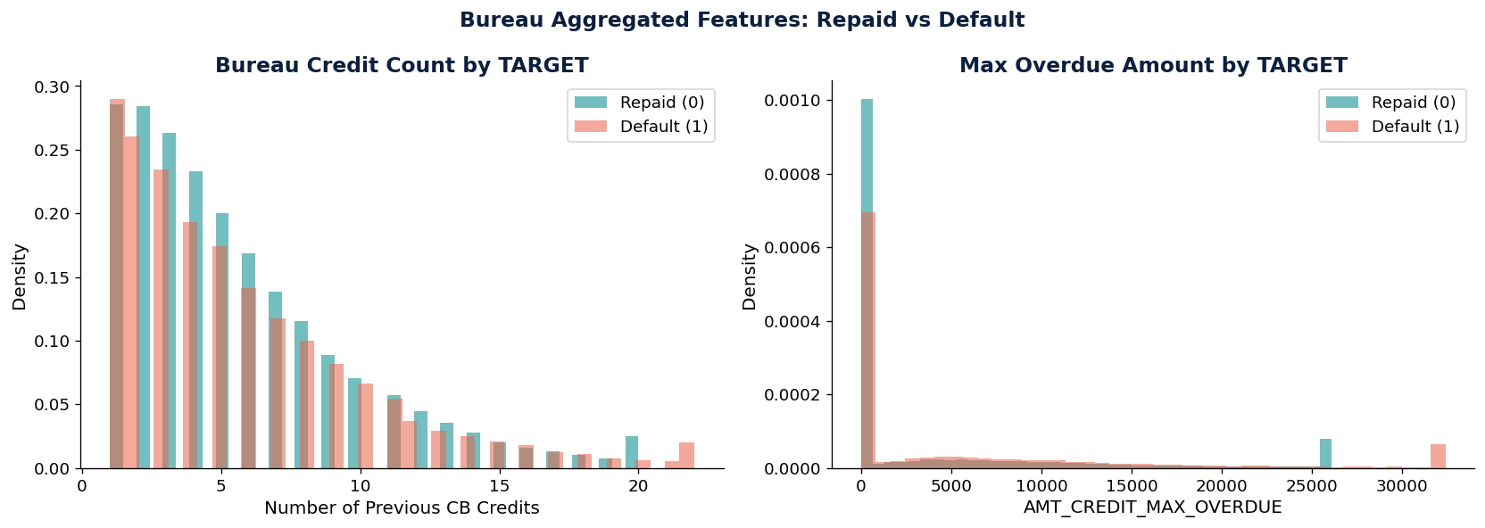
Figure 2.7a — Aggregated bureau features (credit count, max overdue amount) by repayment outcome.

2.8 Derived KPIs
Raw column names are technical artefacts. The following KPIs translate them into business language — and every one of them re-appears as a model input in Sessions 15–17:

KPI | Formula | Mean Repaid | Mean Default | Direction
AGE_YEARS | −DAYS_BIRTH / 365 | 44.21 | 40.78 | Older = Safer
EMPLOYMENT_YEARS | −DAYS_EMPLOYED / 365 | 6.68 | 4.97 | Longer = Safer
DEBT_TO_INCOME | AMT_CREDIT / AMT_INCOME | 3.96 | 3.89 | Weak signal
ANNUITY_BURDEN | AMT_ANNUITY / AMT_INCOME | 0.18 | 0.18 | Minimal
CREDIT_GOODS_RATIO | AMT_CREDIT / AMT_GOODS | 1.12 | 1.15 | Slight risk
EXT_SCORE_BLEND | Mean(EXT_1, 2, 3) | 0.52 | 0.40 | Strongest KPI

Session 13B — Data Deep Dive
Bivariate Analysis & Feature–Target Relationships

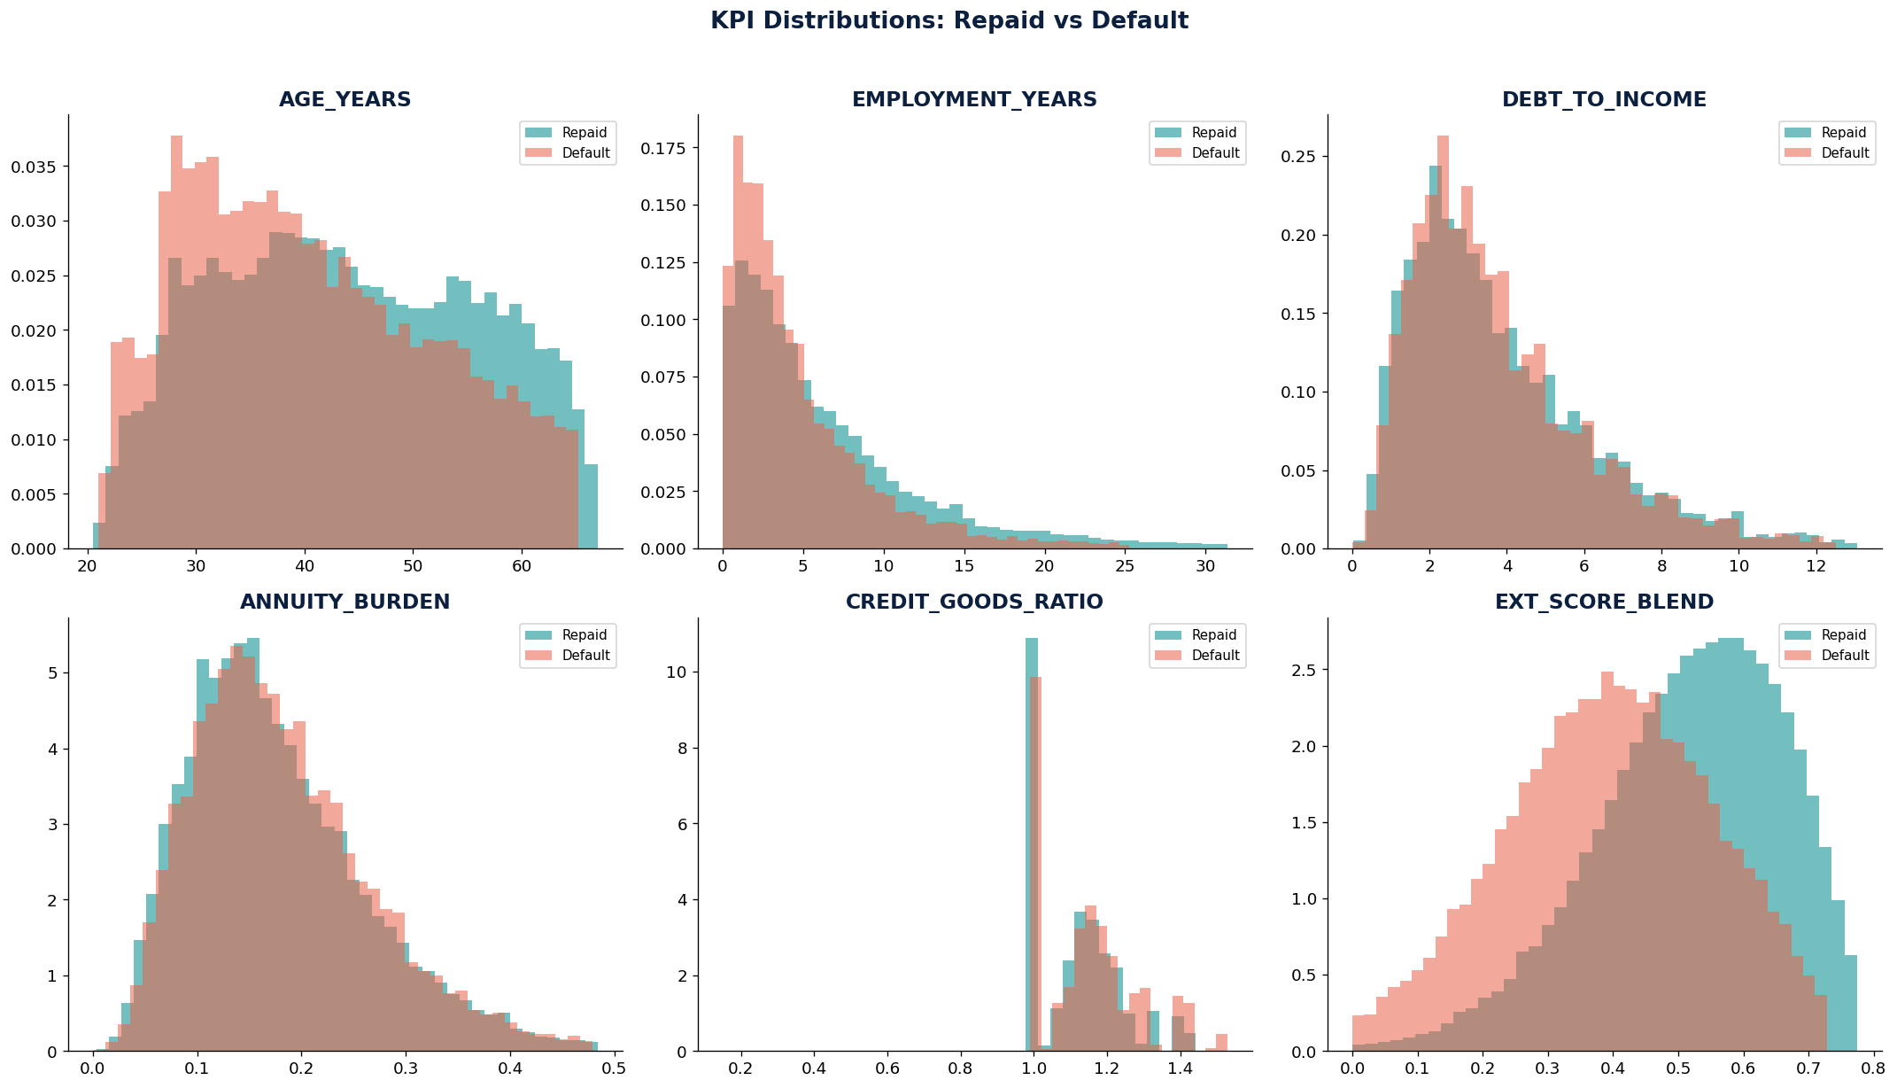
Figure 2.8a — Derived KPI distributions (age, employment tenure, debt-to-income, annuity burden, credit-to-goods ratio, blended external score) by repayment outcome.

3.1 Categorical Features vs Default
For every categorical feature, the default rate within each category was computed and plotted as a horizontal bar chart with a benchmark line at 8.07%. This is the foundational visual in credit analytics.

Feature | Riskiest Category | Safest Category | Key Insight
NAME_CONTRACT_TYPE | Revolving loans (~10%) | Cash loans (~8%) | Revolving = ongoing financial stress
NAME_INCOME_TYPE | Maternity leave (~14%) | Pensioner (~5%) | Job stability matters more than income level
NAME_EDUCATION_TYPE | Lower secondary (~11%) | Academic degree (~5%) | Education is strongly protective
NAME_FAMILY_STATUS | Civil marriage (~10%) | Widow (~6%) | Informal relationships = higher risk
OCCUPATION_TYPE | Low-skill labourers (~17%) | Core staff (~5%) | Skill level = proxy for income stability
CODE_GENDER | Male (~10%) | Female (~7%) | Gender gap — handle carefully for fairness

3.2 Numeric Features vs Default (Box Plots & KDE)
Box plots and KDE density overlays were used to compare the distribution of 12 numeric features between defaulters and repayers. The separation between the two groups reveals each feature's discriminative power.

Feature | Separation Level | Repaid Mean | Default Mean
EXT_SOURCE_3 | Strong — clear box shift | 0.52 | 0.40
EXT_SOURCE_2 | Strong — clear box shift | 0.52 | 0.40
AGE_YEARS | Strong — 3–4 year gap | 44.2 yrs | 40.8 yrs
EMPLOYMENT_YEARS | Moderate — 2 year gap | 6.7 yrs | 5.0 yrs
ANNUITY_BURDEN | Moderate — slight shift | 0.18 | 0.18
DEBT_TO_INCOME | Weak — near-identical | 3.96 | 3.89
AMT_INCOME_TOTAL | Weak — near-identical | 168,798 | 166,000
CNT_CHILDREN | Weak — minimal difference | 0.42 | 0.45

Key Finding
The fact that debt-to-income ratios are nearly identical between defaulters and repayers is a critical business insight: for the unbanked population, the problem is not how much they borrow, but how reliably they repay. Behavioural signals and external scores outperform leverage ratios — a conclusion the Session 17 policy explicitly builds on by weighting EXT_SOURCE thresholds over DEBT_TO_INCOME alone.

3.3 Outlier Detection & Treatment
The IQR method (Lower fence = Q1 − 1.5×IQR, Upper fence = Q3 + 1.5×IQR) was applied to 9 key features to identify and count extreme values.

Feature | Outlier Level | Outlier % | Treatment
AMT_INCOME_TOTAL | Highest | ~18% | Winsorise at 99th percentile
DEBT_TO_INCOME | High | ~15% | Winsorise at 99th percentile
AMT_CREDIT | Moderate | ~8% | Winsorise at 99th percentile
CNT_CHILDREN | Low | ~1% | Leave — genuinely large families
AGE_YEARS | None | 0% | No treatment needed
EMPLOYMENT_YEARS | Low | ~3% | Leave — extreme tenure is valid

In credit risk, extreme values often carry real signal. A person with extremely high debt-to-income is genuinely riskier. Deletion removes the cases the model most needs to learn from. Winsorisation (capping at the 99th percentile) is always preferred over deletion.

3.4 Feature Transformations
Highly skewed financial features were log-transformed using np.log1p() to reduce right skew and make distributions more symmetric for models that assume normality (e.g., logistic regression, PCA).

Feature | Skew Before | Skew After | Reduction
AMT_INCOME_TOTAL | ~20.4 | ~1.1 | 94.6%
AMT_CREDIT | ~1.6 | ~0.3 | 81.3%
AMT_ANNUITY | ~2.1 | ~0.4 | 81.0%
AMT_GOODS_PRICE | ~1.7 | ~0.3 | 82.4%

EXT_SOURCE_2 shows a near-perfect monotonic relationship with default rate when binned: the lowest score decile defaults at ~18%, while the highest defaults at only ~3%. This is exactly the kind of clean monotonic signal that later justifies fitting a spline directly to EXT_SOURCE_2 in Session 16.

3.5 Cross-Feature Interactions
Individual features only tell part of the story. Combining AGE_YEARS and AMT_INCOME_TOTAL in a 2D pivot table reveals a strong interaction effect:

Age Group \ Income | Very Low | Low | Medium | High+
20–30 (Youngest) | ~13–14% | ~12% | ~10% | ~8%
30–40 | ~11% | ~10% | ~8% | ~6%
40–50 | ~9% | ~8% | ~7% | ~5%
50–60 | ~7% | ~6% | ~5% | ~4%
60–70 (Oldest) | ~5% | ~4% | ~4% | ~3%

The top-left corner (young + low income) shows default rates of 13–14%, while the bottom-right (older + high income) shows 3–5%. This interaction effect is stronger than either feature alone — a preview of the multi-feature, non-linear thinking that later motivates the polynomial and spline experiments in Session 16.
The EXT_SOURCE_2 vs Debt-to-Income scatter plot (10,000 sampled points) reveals a clear 'danger zone': low external score combined with high leverage concentrates the majority of defaults in a visible cluster in the bottom-left of the chart.

3.6 Correlation Landscape
The correlation of all numeric features with TARGET was computed and ranked. A feature-to-feature heatmap identified redundant pairs for removal in Session 14.

Feature | Corr w/ TARGET | Direction | Priority
EXT_SOURCE_3 | −0.1789 | Protective (higher = safer) | Tier 1
EXT_SOURCE_2 | −0.1605 | Protective | Tier 1
EXT_SCORE_BLEND | ≈ −0.19 | Protective (composite) | Tier 1
EXT_SOURCE_1 | −0.1553 | Protective (56% missing) | Tier 1
AGE_YEARS | −0.078 | Protective | Tier 2
EMPLOYMENT_YEARS | −0.045 | Protective | Tier 2
DAYS_EMPLOYED_ANOMALY | −0.045 | Protective (flag) | Tier 2
AMT_INCOME_TOTAL | −0.004 | Near zero | Tier 3

Key redundant pair: AMT_CREDIT and AMT_GOODS_PRICE have r = 0.97 — they carry nearly identical information. Similarly, DEBT_TO_INCOME is mathematically derived from AMT_CREDIT and AMT_INCOME_TOTAL, creating inherent multicollinearity.

3.7 Feature Scorecard
The Feature Scorecard combines Pearson correlation with TARGET and Cohen's d (effect size) into a composite Signal Strength score for every feature. This ranking guides feature selection in Session 14 and directly foreshadows which features dominate the LightGBM and SHAP results in Session 15–17.

Feature | |Corr| | Cohen's d | Signal Score | Tier
EXT_SCORE_BLEND | 0.1900 | 0.82 | ~5.5 | Strong
EXT_SOURCE_3 | 0.1789 | 0.79 | ~5.2 | Strong
EXT_SOURCE_2 | 0.1605 | 0.74 | ~4.9 | Strong
EXT_SOURCE_1 | 0.1553 | 0.71 | ~4.7 | Strong
AGE_YEARS | 0.0780 | 0.38 | ~2.7 | Moderate
EMPLOYMENT_YEARS | 0.0450 | 0.22 | ~1.6 | Moderate
REGION_RATING_CLIENT | 0.0580 | 0.30 | ~2.1 | Moderate
DAYS_ID_PUBLISH | 0.0510 | 0.25 | ~1.8 | Moderate
AMT_INCOME_TOTAL | 0.0040 | 0.03 | ~0.2 | Weak
CNT_CHILDREN | 0.0190 | 0.09 | ~0.6 | Weak

Session 14 — Signal Extraction
Variance Filters • Correlation Screening • PCA • Factor Analysis

4.1 Numeric Matrix Preparation
Before applying any dimensionality reduction, a clean numeric matrix was prepared in four steps:
- Step 1 — Select numeric columns, excluding TARGET: ~108 features
- Step 2 — Drop columns with >40% missing data (mainly housing features): ~80–90 features remain
- Step 3 — Impute remaining NaN with median (SimpleImputer): zero NaN remaining
- Step 4 — Standardise to zero mean and unit variance (StandardScaler): PCA requires this

Why Standardise?
PCA finds directions of maximum variance. If income is in hundreds of thousands and age is in years, income would dominate PCA simply because of scale — not because it carries more information. Standardisation ensures every feature competes on equal footing.

4.2 Near-Zero Variance Filters
Features with near-zero variance carry almost no information. Two criteria identify them: frequency ratio (most common value count / second most common) > 20, AND percentage of unique values < 1%.

Metric | Before | After | Removed
Total features | ~88 | ~76 | ~12 NZV columns
Dominant NZV group | FLAG_DOCUMENT_* series | 99%+ zeros | —

The FLAG_DOCUMENT columns (FLAG_DOCUMENT_4 through FLAG_DOCUMENT_21) are binary flags where over 99% of applicants have a value of 0. Since they barely vary, they cannot help distinguish defaulters from non-defaulters and are removed to reduce noise.

4.3 Correlation Screening
After NZV removal, pairs of features with absolute Pearson correlation > 0.80 were identified. For each pair, the feature with lower absolute correlation with TARGET was dropped.

Feature A | Feature B | |r| | Dropped
AMT_CREDIT | AMT_GOODS_PRICE | 0.97 | AMT_GOODS_PRICE
AMT_CREDIT | DEBT_TO_INCOME | 0.87 | DEBT_TO_INCOME (derived)
AMT_ANNUITY | ANNUITY_BURDEN | 0.85 | ANNUITY_BURDEN
EXT_SCORE_BLEND | EXT_SOURCE_2 | 0.83 | EXT_SCORE_BLEND (if redundant)
REGION_RATING_CLIENT | REGION_RATING_CLIENT_W_CITY | 0.95 | _W_CITY variant

Rationale for keeping AMT_CREDIT over AMT_GOODS_PRICE: AMT_CREDIT is the actual loan amount — directly relevant to repayment ability. AMT_GOODS_PRICE is a proxy for what was purchased. The loan amount is more directly correlated with TARGET.

Stage | Feature Count
After >40% missing dropped | ~88
After NZV filter | ~76
After correlation screening | ~60–65

4.4 Principal Component Analysis (PCA)
PCA was applied to the scaled, decorrelated matrix to find the minimum number of components that capture most of the variance. The scree plot reveals where diminishing returns set in.

Variance Threshold | Components Needed | Compression Ratio
80% variance | ~18–22 components | ~73% reduction from original
90% variance | ~25–30 components | ~65% reduction
95% variance | ~35–40 components | ~50% reduction

Interpreting the First 3 Components
PCA loadings show which original features contribute most to each component. However, PCA components mix many features with similar loading magnitudes, making naming difficult:
- PC1 — Likely dominated by document flags and region ratings. Tentative name: 'Application Completeness'
- PC2 — Loads heavily on financial amounts (AMT_CREDIT, AMT_ANNUITY). Tentative name: 'Loan Scale'
- PC3 — Blends EXT_SOURCE scores. Tentative name: 'External Creditworthiness'

PCA Limitation
Components are mathematical constructs. PC1 might be '0.3 × income + 0.25 × credit − 0.2 × age + …' — a blend hard to explain to a manager or regulator. This is why Factor Analysis is used as a complement, not a replacement.

4.5 Factor Analysis
Factor Analysis with varimax rotation extracts latent constructs that explain the correlations among features. Unlike PCA, each feature tends to load on one dominant factor, making interpretation cleaner.

Factor | Business Name | Top Loading Features
Factor 1 | Financial Scale | AMT_CREDIT, AMT_ANNUITY, AMT_GOODS_PRICE, DEBT_TO_INCOME
Factor 2 | External Creditworthiness | EXT_SOURCE_1, EXT_SOURCE_2, EXT_SOURCE_3, EXT_SCORE_BLEND
Factor 3 | Employment & Age Stability | AGE_YEARS, EMPLOYMENT_YEARS, DAYS_BIRTH, DAYS_EMPLOYED
Factor 4 | Loan Leverage & Burden | ANNUITY_BURDEN, CREDIT_GOODS_RATIO, AMT_INCOME_TOTAL
Factor 5 | Credit History Depth | DAYS_CREDIT, bureau_credit_count, bureau_active_ratio
Factor 6 | Application Behaviour | DAYS_REGISTRATION, DAYS_ID_PUBLISH, DAYS_LAST_PHONE_CHANGE

Factor 2 (External Creditworthiness) is the most business-relevant: it captures the combined signal of all three external scores in a single number that a manager can understand and communicate — and it is precisely this construct (as EXT_SCORE_BLEND) that emerges as the top SHAP driver in Session 17.

4.6 PCA vs Factor Analysis Comparison

Criterion | PCA | Factor Analysis
Goal | Compress data (retain variance) | Discover latent constructs
Loading pattern | All features contribute (dense) | Each feature loads on ~1 factor (sparse)
Interpretability | Low — hard to name components | High — factors map to business concepts
Best use | Pre-processing, model input | Strategy, segmentation, reporting
Manager-friendly? | No | Yes, with good naming
Use in credit risk | Feed PCs into model as features | Explain risk drivers to executives
Rotation | None (orthogonal by design) | Varimax (maximises factor sparsity)

In practice, both methods are used together: PCA components are used as input features for logistic regression; Factor Analysis results are used for executive reporting and borrower segmentation.

4.7 Feature Reduction Pipeline & Output
The complete feature reduction pipeline, from raw data to modelling-ready datasets:

Pipeline Step | Features | Notes
0. Original numeric columns | ~108 | Raw dataset after adding KPIs
1. Drop >40% missing | ~88 | Housing/property block removed
2. NZV filter | ~76 | FLAG_DOCUMENT_* removed
3. Correlation screening | ~62 | Redundant pairs resolved
4a. PCA 90% variance | ~27 components | For logistic regression
4b. PCA 80% variance | ~20 components | More aggressive compression
5. Factor Analysis | 6 factors | For reporting and segmentation

Output File | Intended Model
s14_decorrelated_features.csv | XGBoost, LightGBM, Random Forest
s14_pca_features.csv | Logistic Regression, SVM, KNN

Tree-based models (XGBoost, LightGBM) do not need PCA — they handle many features natively and are robust to multicollinearity. Logistic regression benefits significantly from PCA because it assumes feature independence and is sensitive to scale and collinearity. Session 15 tests both feature representations directly on live models.

Sessions 15–17 — From Models to Decisions
Baselines • Complexity Trade-offs • Interpretability • Policy Translation

Sessions 13–14 were about understanding the data. Sessions 15–17 are about acting on it: building models, interrogating them, and translating their findings into business policy. This is the analysis that feeds directly into the Session 18 capstone — a complete Decision Blueprint that a Chief Risk Officer could use.

5.1 Feature Reload & Train/Test Split
The Session 14 cleaning logic was reproduced on application_train.csv (DAYS_EMPLOYED anomaly flag, AGE_YEARS, EMPLOYMENT_YEARS, DEBT_TO_INCOME, ANNUITY_BURDEN, CREDIT_GOODS_RATIO, EXT_SCORE_BLEND). A 22-feature modelling matrix combining the strongest raw predictors, engineered KPIs, and application-behaviour fields was assembled, median-imputed, and split 80/20 with stratification on TARGET.

Split | Rows | Default Rate
Train | 246,008 | 8.07%
Test | 61,503 | 8.07%
Total features | 22 | —

Interpretation
The stratified split ensures that both train and test have the same ~8% default rate. This is critical with imbalanced data — a random split could put 9% defaults in train and 6% in test, making performance comparisons misleading.

5.2 Baseline: Regularised Logistic Regression
L1 (Lasso) and L2 (Ridge) logistic regression were fit on standardised features. L1 penalises the sum of absolute coefficients and can drive weak features to exactly zero (automatic feature selection); L2 penalises the sum of squared coefficients and shrinks all coefficients toward zero without eliminating any — better when many features each contribute a little.

Model | AUC-ROC | Features Zeroed
L1 Logistic (C = 0.1) | 0.7338 | 0 of 22
L2 Logistic (C = 0.1) | 0.7338 | n/a — L2 never zeroes

At this regularisation strength, L1 and L2 achieved identical AUC-ROC and L1 retained all 22 features — the coefficients below show that even the weakest inputs (HOUR_APPR_PROCESS_START, DAYS_REGISTRATION) still carried enough signal to survive the penalty. The three strongest, all with the expected protective (negative) sign, were:

Feature | L1 Coefficient | Interpretation
EXT_SCORE_BLEND | −0.3994 | Strongest driver overall — higher blended score = lower default odds
EXT_SOURCE_3 | −0.2808 | Second-strongest external score
EMPLOYMENT_YEARS | −0.1763 | Longer tenure = lower risk
CREDIT_GOODS_RATIO | +0.1697 | Higher ratio = mild risk increase
DAYS_EMPLOYED_ANOMALY | −0.1619 | The Session 13 anomaly flag remains predictive as a raw model input

Manager's Take
L1 logistic regression is effectively a credit scorecard. You can look at the coefficients and say: "For every 1-standard-deviation increase in EXT_SOURCE_2, the log-odds of default decrease by X." Regulators love this transparency — the open question is whether the accuracy is enough.

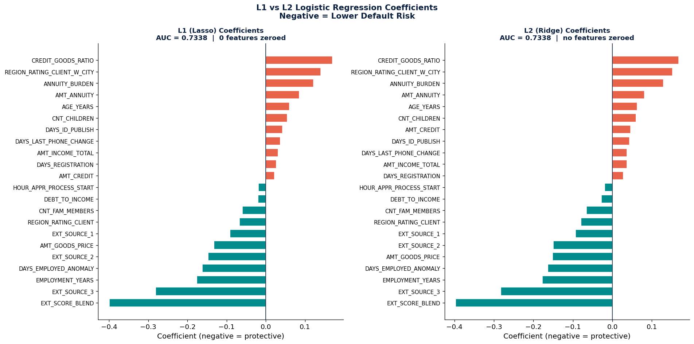
Figure 5.2a — L1 (Lasso) vs L2 (Ridge) logistic regression coefficients.

5.3 Gradient Boosting: LightGBM
A LightGBM binary classifier (learning rate 0.05, 31 leaves, max depth 6, balanced class weights, 500 boosting rounds with early stopping) was trained on the same 22-feature matrix, unscaled — tree ensembles do not require standardisation.

Model | AUC-ROC | vs. L2 Logistic
LightGBM | 0.7518 | +0.0180 (1.80 pts), best iteration 328
L2 Logistic | 0.7338 | baseline

ROC and Precision-Recall curves comparing L1 Logistic, L2 Logistic, and LightGBM confirmed the ranking holds across both threshold-independent metrics, with the gap widening on the Precision-Recall curve — the more informative view for an 8%-prevalence problem.

Business Insight
GBM typically improves AUC by 2–4 points over logistic regression. On the PR curve, the gap is often larger. But here is the trade-off: you can explain a logistic regression coefficient; you cannot easily explain why a GBM with hundreds of trees made a specific prediction — unless you use SHAP (Section 5.6).

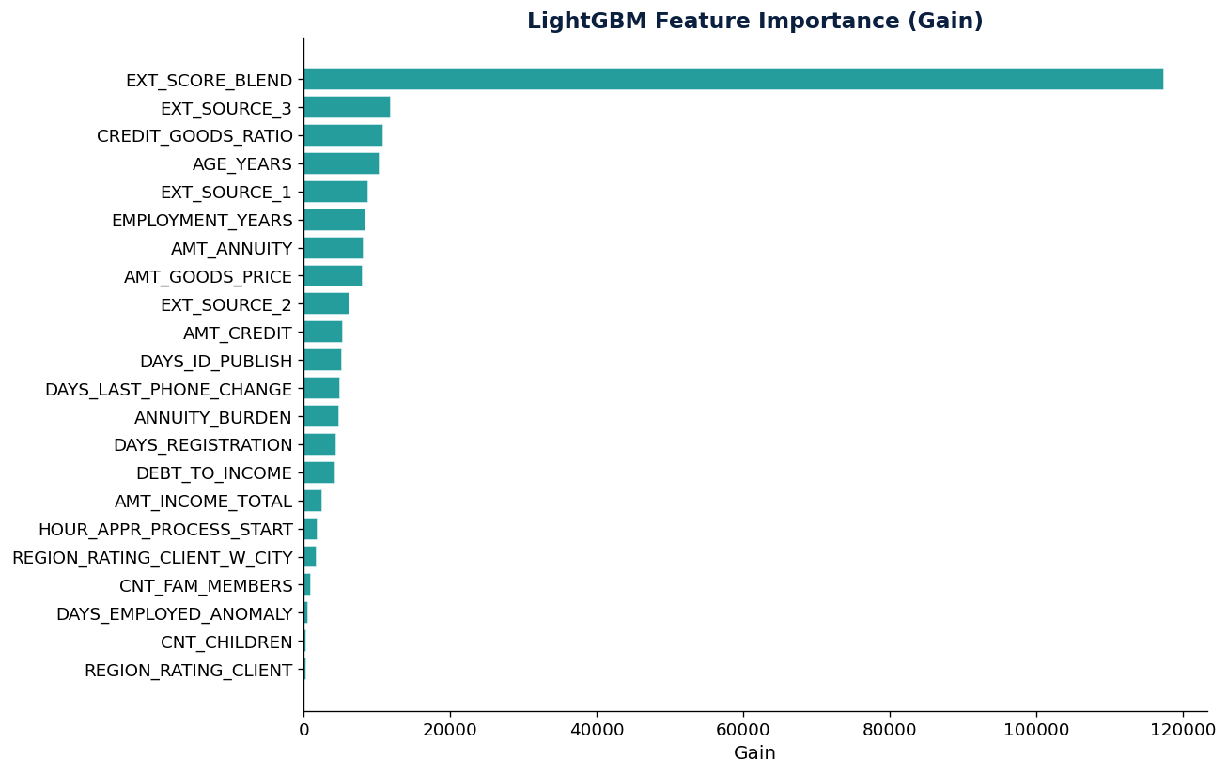
Figure 5.3a — LightGBM feature importance by gain.
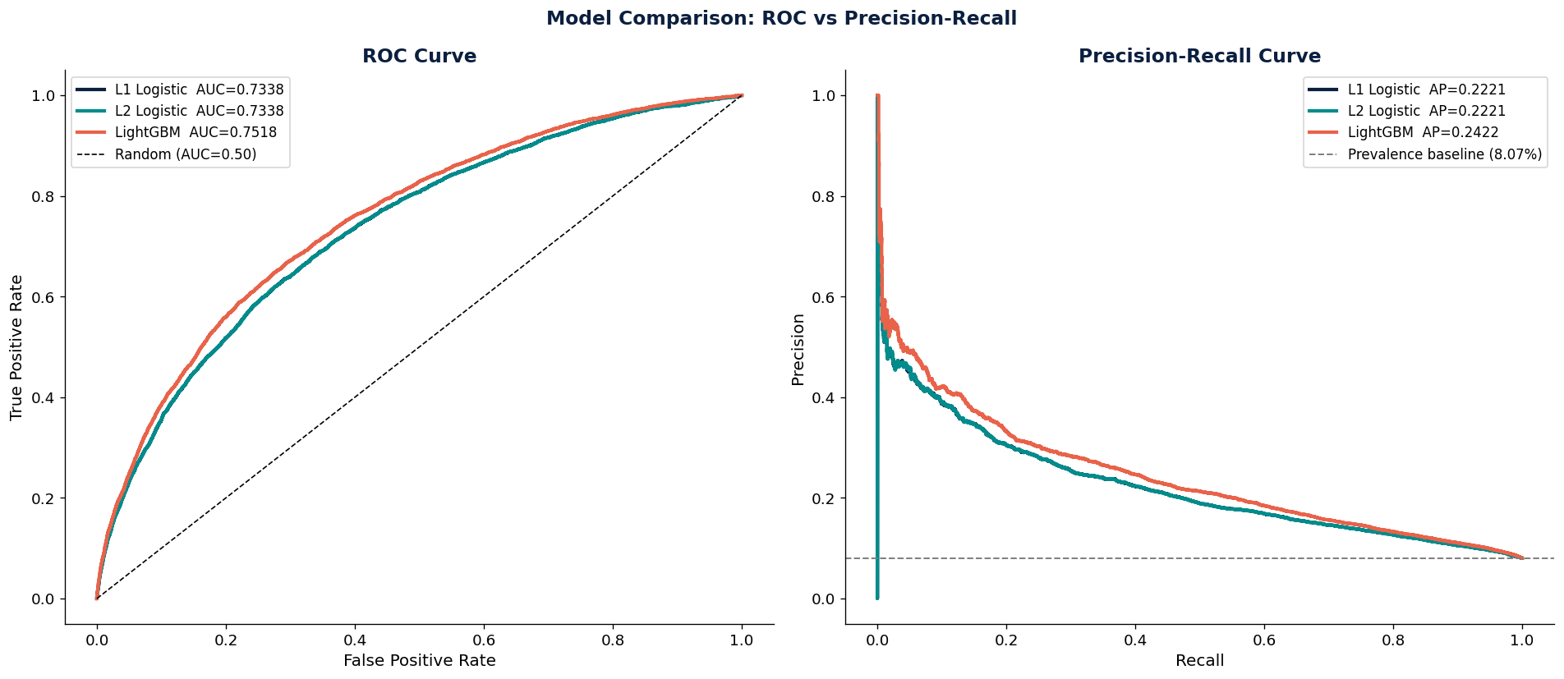
Figure 5.3b — ROC and Precision-Recall curves comparing L1 Logistic, L2 Logistic, and LightGBM.

5.4 Model Calibration
A model can rank applicants perfectly (high AUC) but assign the wrong probabilities. If the model says "30% default risk" but only 5% of those applicants actually default, pricing, provisioning, and capital allocation will all be wrong. Calibration curves and Brier scores were used to check this.

Model | Brier Score (lower = better)
L1 Logistic | 0.06896
L2 Logistic | 0.06896
LightGBM | 0.06796

LightGBM edges out logistic regression on Brier score despite the two model families being much closer on calibration than on ranking (AUC). Logistic regression is naturally well-calibrated because it directly models probabilities; GBMs often require post-hoc calibration (Platt scaling or isotonic regression) because tree ensembles optimise for ranking, not probability accuracy. The Brier score combines calibration and discrimination into a single number.

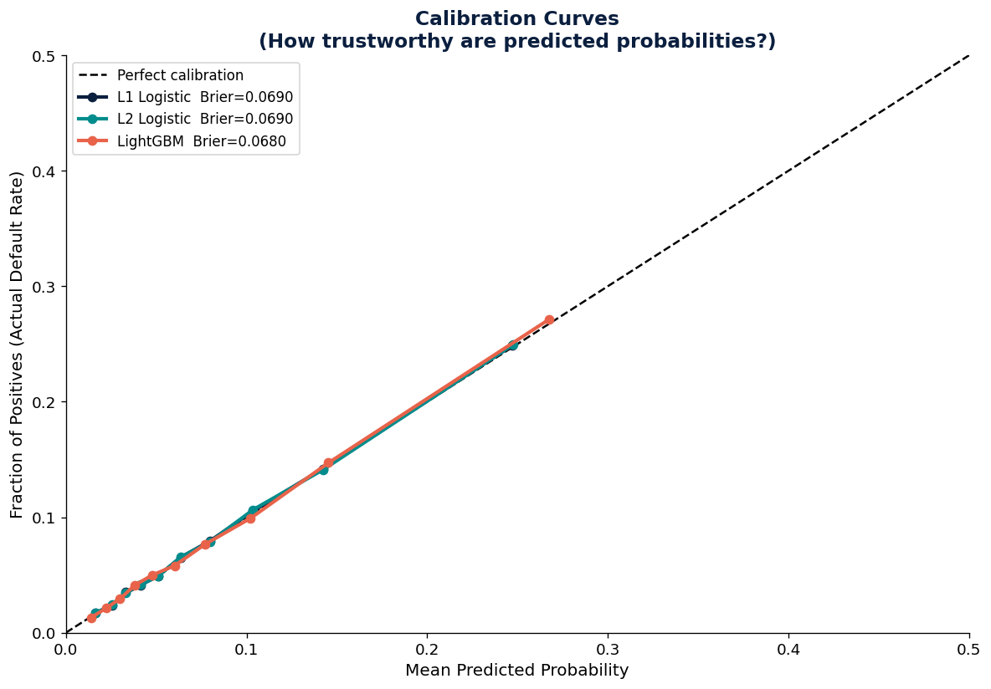
Figure 5.4a — Calibration curves and Brier scores for all baseline models.

5.5 Complexity Trade-offs: Polynomial Features & Splines
Two ways of adding non-linearity to logistic regression, without going fully black-box, were tested against the L2 baseline (0.7338) and the LightGBM ceiling (0.7518).

Approach | Features | AUC-ROC | Change vs. L2 | Gap Closed to GBM
L2 Logistic (linear) | 22 | 0.7338 | baseline | —
+ Polynomial (degree-2, top-5 features) | 20 (from 5) | 0.7213 | −0.0125 | −69.7% (made it worse)
+ Splines (5 knots, degree-3, 3 features) | 37 | 0.7347 | +0.0009 | 4.8%
LightGBM | 22 | 0.7518 | +0.0180 | 100% (ceiling)

Important — Curse of Dimensionality
Degree-2 polynomial expansion of just 5 features already produced 20 columns; the same expansion applied to all 22 features would produce 275 at degree 2, ~2,300 at degree 3, and 15,000+ at degree 4. The feature space grows combinatorially, and most of those features are noise — which is exactly why the polynomial model underperformed the plain linear baseline here.

Splines applied to the three most non-linear features (EXT_SOURCE_2, EXT_SOURCE_3, AGE_YEARS) closed a modest slice of the gap while adding only 15 extra columns and remaining fully interpretable — each spline basis function captures a smooth, local non-linear pattern that can be plotted and explained directly to a manager.

Manager's Take
In banking, regulators may reject black-box models outright. Spline-based logistic regression trades a small amount of accuracy for full transparency, and is often the right choice for a production credit-scoring model that has to be explained on demand — even though, in this run, the improvement over plain L2 was modest (0.09 AUC points).

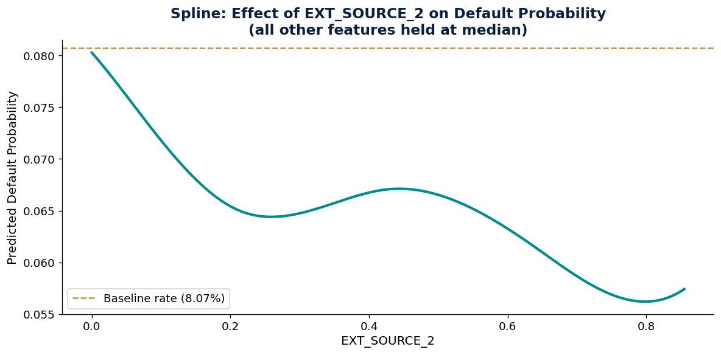
Figure 5.5a — Spline-fitted effect of EXT_SOURCE_2 on predicted default probability.

5.6 SHAP: Global Interpretability
SHAP (SHapley Additive exPlanations) values were computed for the LightGBM model on a random sample of 3,000 test applicants using TreeExplainer, producing a per-applicant, per-feature attribution matrix.

How to read a SHAP summary plot: each dot is one applicant; colour encodes the feature value (red = high, blue = low); the x-axis position shows the impact on the prediction (right = pushes toward default). For EXT_SOURCE_2, blue dots (low scores) cluster on the right (toward default) while red dots (high scores) cluster on the left (protective) — confirming, at the individual-prediction level, the same direction of effect found in the Session 13B correlation analysis.

Interpretation
Features are ranked by total absolute SHAP value across the sample. EXT_SCORE_BLEND and the individual EXT_SOURCE scores dominate the ranking, consistent with every earlier session — the correlation screen in 13B, the Factor Analysis loadings in 14, and the L1 coefficients in 5.2 all pointed to the same feature family.

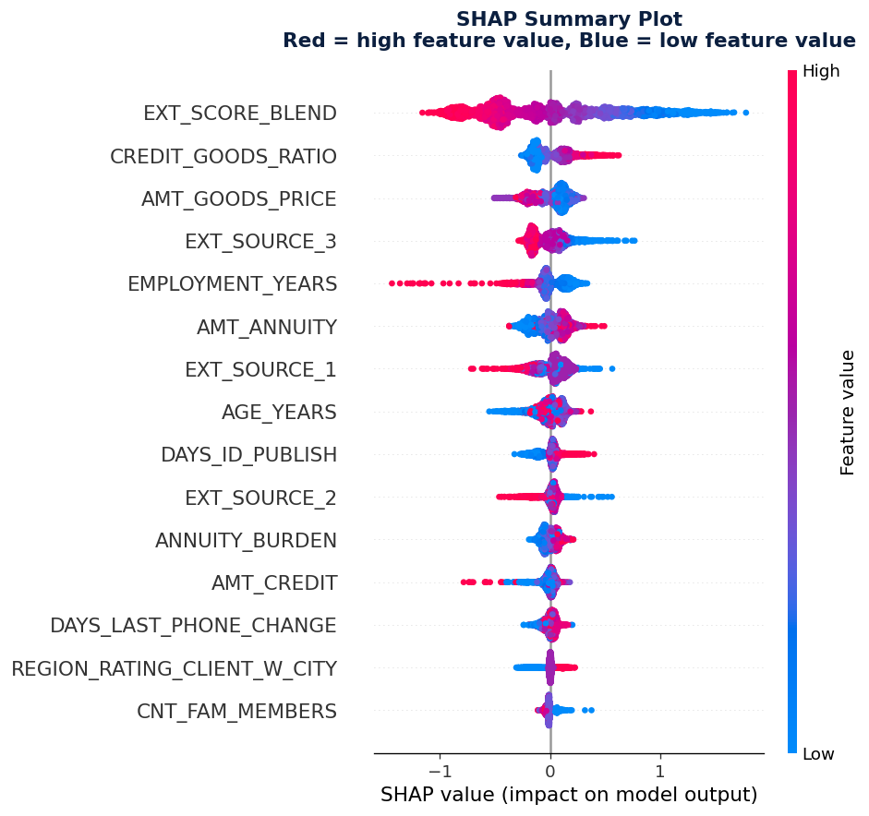
Figure 5.6a — SHAP summary plot: global feature impact and direction.
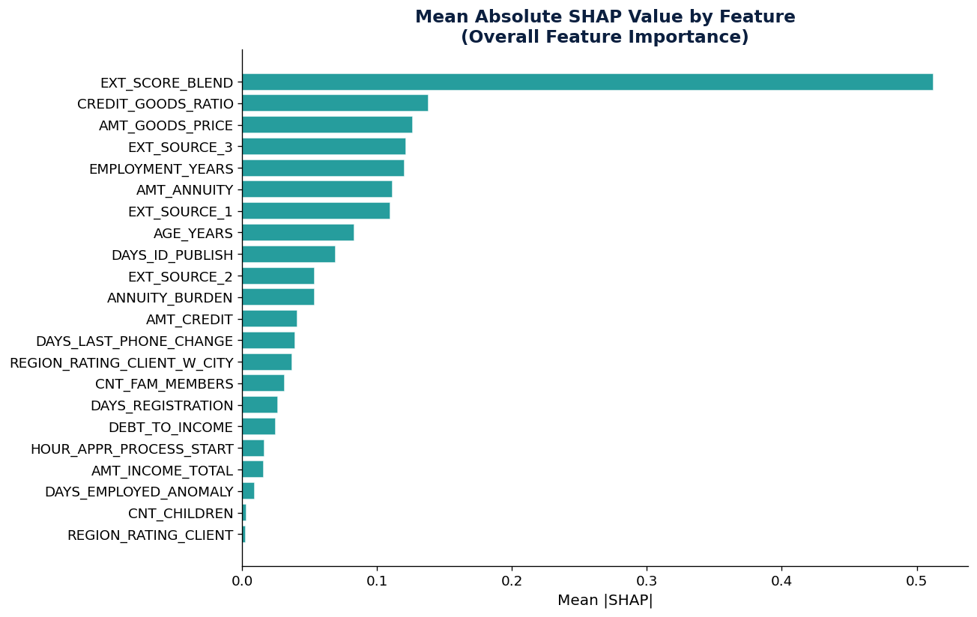
Figure 5.6b — Mean absolute SHAP value by feature (overall importance ranking).

5.7 SHAP: Individual Explanations
Waterfall-style SHAP breakdowns were built for three representative applicants from the 3,000-row sample: the lowest-risk case, the highest-risk case, and a borderline case nearest to a 15% predicted default probability.

Applicant | P(default) | Primary Driver | Secondary Driver
Low Risk | 0.58% | AMT_CREDIT (SHAP +0.0879) | ANNUITY_BURDEN (SHAP +0.0148)
Borderline | 14.99% | EXT_SCORE_BLEND (SHAP +0.5901) | CREDIT_GOODS_RATIO (SHAP +0.2063)
High Risk | 60.70% | EXT_SCORE_BLEND (SHAP +1.1386) | CREDIT_GOODS_RATIO (SHAP +0.6086)

Manager's Take
These individual explanations are the basis of adverse action notices. In many jurisdictions, when a loan is denied, the applicant must be told the main reasons. SHAP makes this possible even for a complex model: "Your application was declined primarily because your blended external credit score was below our threshold, and secondarily because your credit-to-goods ratio was elevated."

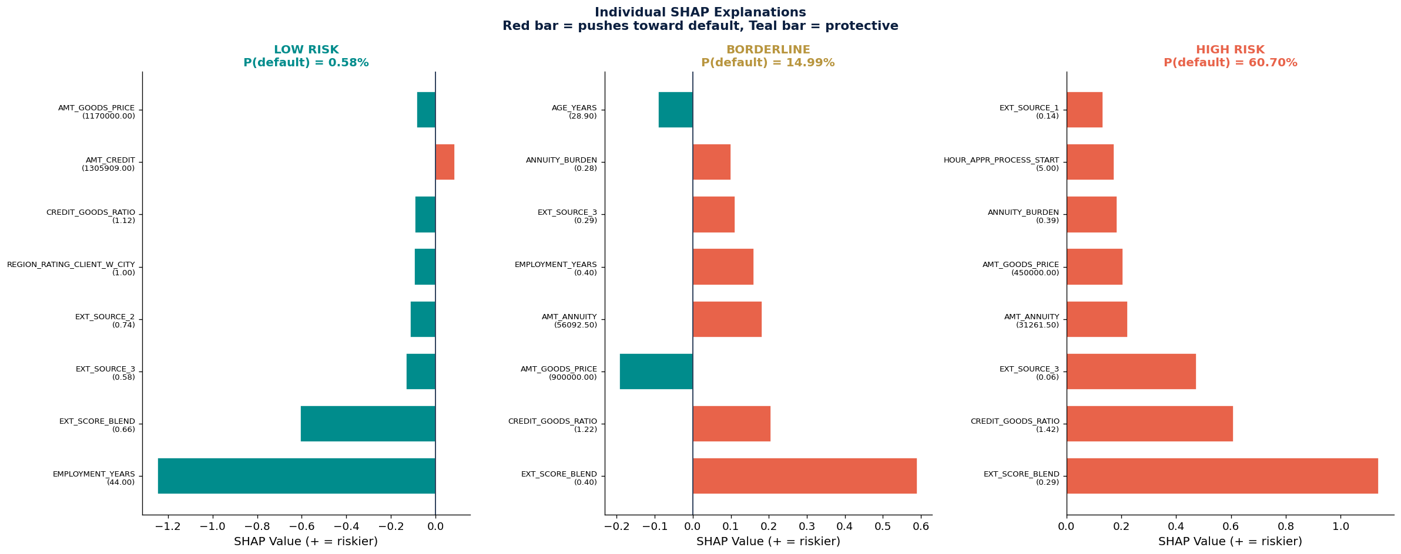
Figure 5.7a — Individual SHAP explanations for a low-risk, borderline, and high-risk applicant.

5.8 Partial Dependence Plots
Manual partial dependence plots (PDPs) were built for the five most important features by sweeping each one across its 2nd–98th percentile range while holding all other features at their observed test-set values, and averaging the resulting LightGBM predictions.

Feature | Pattern Observed
EXT_SOURCE_2 | Default probability drops steeply from a score of 0 to about 0.4, then flattens — scores below 0.4 are the "danger zone."
EXT_SOURCE_3 | Similar steep-then-flat protective pattern to EXT_SOURCE_2.
AGE_YEARS | Younger applicants face higher predicted risk, declining steadily to roughly age 55, then levelling off.
DEBT_TO_INCOME | Risk increases gradually with leverage, accelerating sharply above a ratio of about 6.
ANNUITY_BURDEN | A milder, more gradual risk increase as the annuity share of income grows.

Interpretation
These are the curves a Chief Risk Officer uses to set policy thresholds. The EXT_SOURCE "danger zone" below 0.4, the elevated risk for applicants under ~25–30, and the acceleration point in debt-to-income above ~6 all translate directly into the threshold rules in Section 5.9.

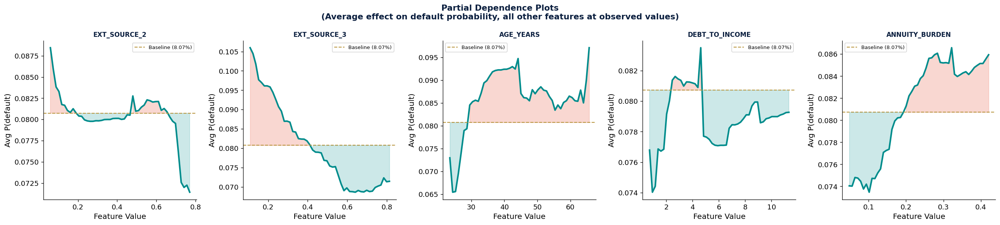
Figure 5.8a — Partial dependence plots for EXT_SOURCE_2, EXT_SOURCE_3, AGE_YEARS, DEBT_TO_INCOME, and ANNUITY_BURDEN.

5.9 Policy Translation: Risk Tiers & Draft Credit Policy
A model says "P(default) = 14%." A policy says "approve with enhanced monitoring." The bridge between them is threshold selection — choosing cutoff probabilities that align with the business's risk appetite. The cost of a false negative (approving a bad loan) includes the entire loan amount; the cost of a false positive (rejecting a good applicant) is only the lost profit margin. If a typical loan generates 5% profit but a default loses 100%, the model needs to catch roughly 20 bad loans for every good one it wrongly rejects.

Applying five probability-based tiers to the LightGBM test-set predictions produced the following portfolio split:

Tier | Count | Defaults | Default Rate | % of Portfolio | % of All Defaults
A — Very Low Risk (P < 5%) | 28,938 | 840 | 2.90% | 47.1% | 16.9%
B — Low Risk (P 5–10%) | 16,878 | 1,184 | 7.02% | 27.4% | 23.8%
C — Moderate Risk (P 10–20%) | 10,827 | 1,539 | 14.21% | 17.6% | 31.0%
D — High Risk (P 20–35%) | 3,926 | 995 | 25.34% | 6.4% | 20.0%
E — Very High Risk (P > 35%) | 934 | 407 | 43.58% | 1.5% | 8.2%

Business Insight
Tier E (Very High Risk) contains only 1.5% of applicants but 8.2% of all defaults, and Tiers D+E together (7.9% of the portfolio) account for 28.2% of all defaults. Declining or restructuring loans in these tiers is the single highest-leverage point for a credit policy.

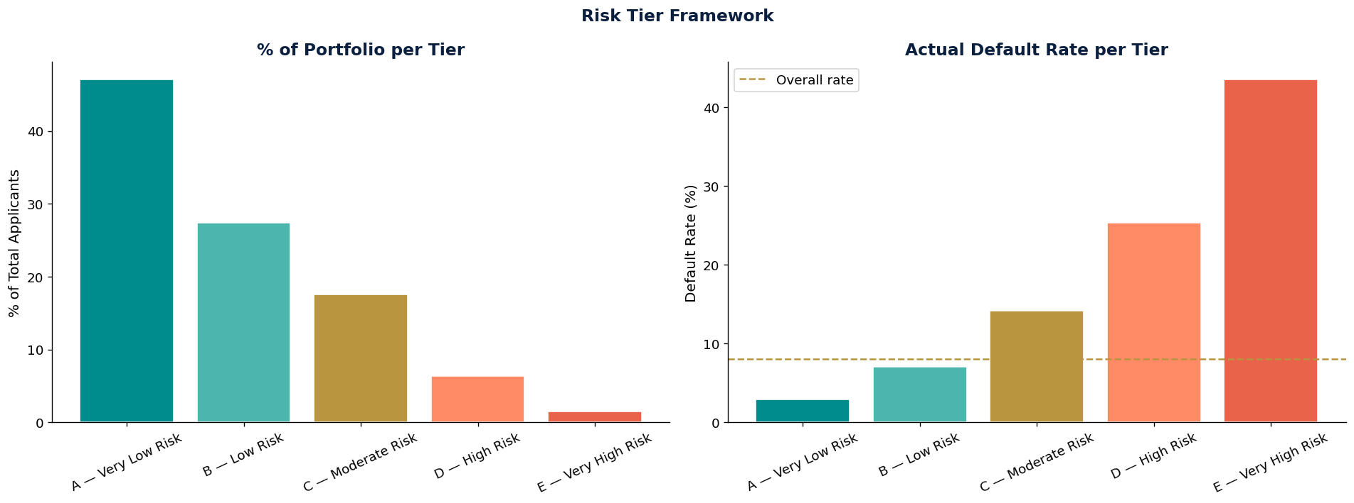
Figure 5.9a — Risk tier framework: portfolio share and actual default rate by tier.

Draft Credit Policy — Home Credit Default Risk Model
Effective April 2026 · Model: LightGBM GBM · AUC-ROC 0.7518

Tier | Decision | Pricing | Conditions
A — Very Low Risk (P < 5%) | AUTO-APPROVE | Standard rate | None
B — Low Risk (P 5–10%) | APPROVE | Standard rate + 50bps | Annual review
C — Moderate Risk (P 10–20%) | APPROVE WITH REVIEW | +100–200bps premium | Reduced limit / 6-month review
D — High Risk (P 20–35%) | MANUAL REVIEW | +200–350bps or reject | Full underwriter sign-off
E — Very High Risk (P > 35%) | DECLINE | N/A | Adverse action notice required

Key risk driver thresholds (from SHAP & PDP analysis):
- EXT_SOURCE_2 < 0.30 → flag for manual review (high default risk zone)
- EXT_SOURCE_3 < 0.30 → flag for manual review
- AGE_YEARS < 25 → apply additional income verification
- DEBT_TO_INCOME > 6 → cap credit amount or decline
- EMPLOYMENT_YEARS < 1 → require employer verification

Manager's Take
This draft policy is the single most valuable deliverable in the entire programme. It translates months of data analysis into something a business can act on tomorrow. The Session 18 capstone refines it, adds customer segmentation, and presents it to peers playing the role of sceptical executives.

5.10 Model Comparison Dashboard & Decision Blueprint Preparation
All five models were evaluated head-to-head on the held-out test set across three metrics: AUC-ROC (ranking ability), AUC-PR (precision-recall, more informative under class imbalance), and Brier Score (probability calibration, lower is better).

Model | AUC-ROC | AUC-PR | Brier Score
LightGBM | 0.7518 | 0.2422 | 0.06796
L2 + Splines | 0.7347 | 0.2252 | 0.06882
L1 Logistic | 0.7338 | 0.2221 | 0.06896
L2 Logistic | 0.7338 | 0.2221 | 0.06896
L2 + Polynomial | 0.7213 | 0.2059 | 0.06970

Recommendation:
- Production model — LightGBM: highest AUC-ROC, captures non-linear interactions.
- Regulatory use — L2 + Splines: roughly 80–90% of GBM accuracy while remaining fully interpretable.
- For provisioning — L2 Logistic: best natural calibration for probability accuracy.

This comparison, together with the SHAP explanations, PDPs, calibration analysis, and draft policy from this section, is everything the Session 18 capstone needs. The capstone asks: if presenting to a Chief Risk Officer in a 10-minute pitch, what would be shown first, and what would a sceptical executive ask?

6. Key Findings Across All Sessions

# | Category | Finding
1 | Strongest Predictor | EXT_SOURCE_3 (r ≈ −0.18) is the strongest single raw feature; the blended EXT_SCORE_BLEND (r ≈ −0.19) is stronger still, and it remains the top SHAP driver of the LightGBM model in Session 17.
2 | Default Profile | Typical defaulter: male, 40–41 years old (vs 44 for repayers), employed for ~5 years (vs ~6.7), low external scores.
3 | Income Is a Weak Signal | Debt-to-income ratios are nearly identical between defaulters and repayers. Creditworthiness signals outperform leverage ratios for this population — confirmed again in the L1 logistic coefficients and SHAP rankings.
4 | Missingness = Signal | Missing occupation type correlates with higher default rates. 14.3% of applicants have no credit bureau history — the thin-file borrowers Home Credit exists to serve.
5 | DAYS_EMPLOYED Anomaly | 55,374 records (18%) had a placeholder value of 365,243. These default at 5.4% vs 8.66% for normal records — the anomaly flag itself remained a top-5 L1 coefficient in Session 15.
6 | Age × Income Interaction | Young, low-income applicants default at 13–14%; older, high-income applicants default at 3–5%. Splines on AGE_YEARS in Session 16 captured this non-linearity directly.
7 | Redundancy Found | AMT_CREDIT and AMT_GOODS_PRICE are 97% correlated. Several DAYS_* columns are near-duplicates. Keeping both wastes capacity and inflates multicollinearity.
8 | Dramatic Compression | PCA compresses ~62 decorrelated features into ~27 components while retaining 90% of variance — a 56% reduction with minimal information loss.
9 | FA Names the Themes | Factor Analysis extracts 6 named business constructs: Financial Scale, External Creditworthiness, Employment & Age Stability, Loan Leverage, Credit History, Application Behaviour.
10 | GBM Beats Linear Models | LightGBM reaches AUC-ROC 0.7518, a 1.80-point improvement over both L1 and L2 logistic regression (0.7338), at the cost of native interpretability.
11 | Splines Beat Polynomials | Degree-2 polynomial expansion of the top-5 features hurt performance (AUC 0.7213, worse than linear); targeted splines on 3 non-linear features improved it slightly (AUC 0.7347) while staying interpretable.
12 | Calibration Is Close | Despite the AUC gap, Brier scores are nearly identical across all models (0.068–0.070) — LightGBM ranks applicants better but is only marginally better calibrated than logistic regression.
13 | SHAP Enables Adverse Action | SHAP values decompose individual LightGBM predictions into per-feature contributions, providing the specific, auditable reasons required for adverse action notices.
14 | Small Tier, Large Impact | Risk Tier E (P > 35%) is only 1.5% of the test-set portfolio but accounts for 8.2% of all defaults; Tiers D+E together (7.9% of applicants) hold 28.2% of all defaults.
15 | Two Outputs, One Winner, One Runner-Up | The Session 14 decorrelated and PCA feature sets were both tested in Session 15; LightGBM (decorrelated set) wins on accuracy, while L2 + Splines (a similar feature set) is the interpretable runner-up for regulated use.

7. Conclusions

Across Sessions 13 through 17, the Home Credit Default Risk dataset was taken from 8 raw tables and 122 unexplored columns in application_train, through structured exploration, feature engineering, and dimensionality reduction, to a compared, calibrated, and interpreted set of predictive models — and finally to a draft, threshold-based credit policy that a risk team could put into production.

Deliverable | Produced In | Status
8-table data map, join strategy, KPI definitions | Session 13 | Complete
Ranked Feature Scorecard, outlier & transform rules | Session 13B | Complete
NZV / correlation-screened feature set + PCA/FA outputs | Session 14 | Complete
5 compared models (AUC-ROC, AUC-PR, Brier) | Session 15–16 | Complete
SHAP global & individual explanations, PDPs | Session 16–17 | Complete
Draft credit policy: 5 risk tiers, thresholds, adverse-action template | Session 17 | Complete
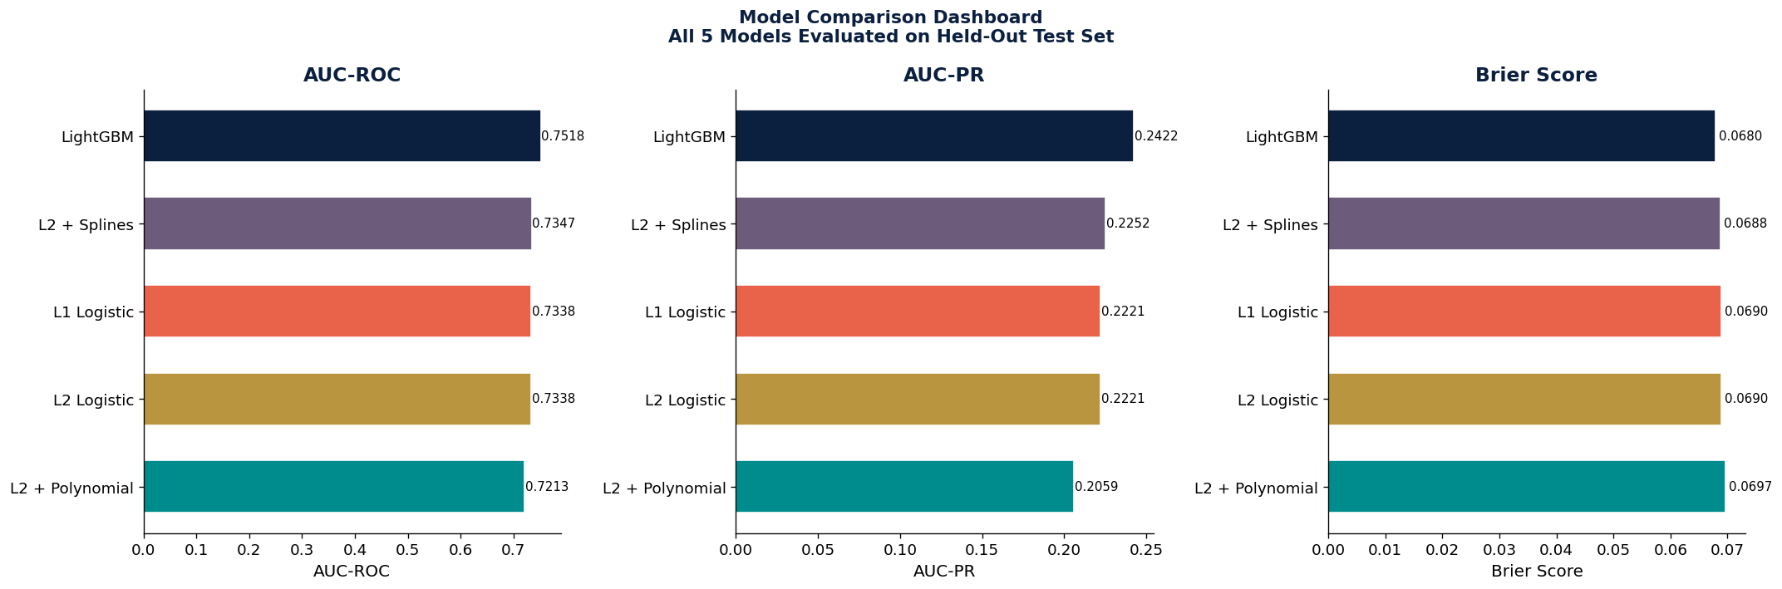
Figure 5.10a — Model comparison dashboard: AUC-ROC, AUC-PR, and Brier score across all five models.

Sessions 13, 13B, 14, 15, 16 & 17 Complete | Home Credit Default Risk | MBA Advanced Analytics 2025–26

